HANOI UNIVERSITY
FACULTY OF INFORMATION TECHNOLOGY
61FIT3REQ – Software Requirement Analysis
---------o0o---------

SRS REPORT
HaNova Academic Mentoring Platform
Group 04 - Tutorial 05
Instructor: Mr. Hoang Ngoc Duy
Group members:
Nguyễn Thế Nam - 2301040131
Phạm Thu Thảo - 2301040172
Tạ Thùy Linh - 2301040104
Đặng Thị Tuyết Nhung - 2301040143
Lê Thị Thùy Trang - 2301040180
Nguyễn Mạnh Hà - 2301040056

Hanoi, April 2026
HaNova Academic Mentoring Platform

INTRODUCTION
With the increasing demand for academic support, better management of tutoring services is required. The HaNova Academic Mentoring Platform focuses on improving the management of tutoring activities in a centralized and efficient way. “What if students can search for a suitable tutor, check availability, and book sessions through a single platform?” or “what if instead of manual scheduling and payments, everything can be done online easily?”. The HaNova Academic Mentoring Platform provides the ease of searching tutors, booking sessions, managing schedules, and making payments through a web-based system. The platform is designed to ensure efficiency, transparency, and reliability in tutoring services. It mainly focuses on tutor discovery, booking, scheduling, and payment management..

1.1. PURPOSE
The purpose of the project is to replace fragmented and manual tutoring center operations with a unified, automated online system. The main purpose of this project is to maintain an easy and efficient interaction system between students and tutors, to allow students to search and book tutors, and to manage scheduling and payments. It also aims to build a trusted environment through a rigorous tutor verification and approval process, ensuring only qualified mentors are accessible to students. Moreover, users can access all these features online from anywhere.

1.2. SCOPE
The system focuses on digitizing and automating core functionalities of an academic mentoring platform, covering the following functional areas: tutor management, student management, session booking and scheduling, online payment processing, automated notifications, and review and complaint handling.
- Students can search for tutors using advanced filters (subject, availability, price, rating), view detailed profiles, book mentoring sessions, manage their personal study schedule, and make secure online payments directly through the platform.
- Tutors are provided with tools to manage their profiles, set their availability, confirm bookings, and receive notifications for all session activities.
- The platform includes a management dashboard for center secretaries and administrators to approve tutor profiles, monitor KPIs such as revenue and booking statistics, handle user complaints, and oversee overall platform operations.
- The system does not include AI-based tutor recommendation or complex third-party integrations in this initial phase. The scope is focused on delivering a stable, user-centric core platform covering the complete tutoring workflow from search to payment.

1.3 Definition, Acronyms, Abbreviation
- KPI: Key Performance Indicators
- API: Application Programming Interface
- SQL: Structured query Language
- DFD: Data Flow Diagram
- ER: Entity Relationship
- SRS: Software Requirement Specification
- HR: Human Resources
- OVERALL DESCRIPTION
2.1 PRODUCT PERSPECTIVE
The HaNova Academic Mentoring Platform is a standalone, web-based application designed to streamline and automate the core operations of an academic tutoring center. The booking, scheduling, and payment processes will update the system automatically so that users will always get the latest information. The system is a standalone web-based application used by students, tutors, managers, and administrators. It supports integration with services such as payment gateways (VNPay, MoMo), notification systems, and calendar APIs. The platform can be deployed on a cloud server or local server and is accessible through web browsers on multiple devices such as desktop, tablet, and mobile, ensuring a consistent and consistent experience for all users.
2.2. SOFTWARE REQUIREMENT
- Front end:
  - Web browser: Chrome, Safari.
  - OS support: Windows 10+, macOS
- Backend:
  - Programming language: Node.js
- Database: MongoDB
2.3. HARDWARE REQUIREMENT
- Storage: 1B

2.4.1. FUNCTIONAL REQUIREMENT
- R.1: Register
    - Description: First, the user will have to register/sign up to access the platform. There are four different types of users: Administrator, Manager, Tutor, and Student.
    - Manager/Administrator: Must provide details about the center's name, office address, phone number, and official email.
    - Tutor: Must provide full name, contact details, qualifications, experience, subjects taught, and pricing.
    - Student: Must provide name, address, phone number, email, and learning goals.
- R.1.1: Sign up
    - Input: Personal and professional details as mentioned in the description.
    - Output: Confirmation of registration status. An account ID and temporary password will be generated and sent to the user’s email.
    - Processing: The system validates all input fields for formatting and duplicates. If errors are found, an error message is displayed; otherwise, the account is created in a "Pending" status for Tutors or "Active" for Students.
- R.1.2: Login
    - Input: Enter the registered Membership ID/Email and password.
    - Output: The user will be authenticated and redirected to their respective dashboard (Student, Tutor, or Manager).
- R.2: Manage Tutoring Sessions
- R.2.1: Search Tutors
    - Description: Students can browse and filter the list of available mentors.
    - Input: Enter keywords such as subject name, price range, or tutor rating.
    - Output: A list of verified tutors matching the specific criteria.
- R.2.2: Book Lesson
    - Description: Students select a specific time slot for a mentoring session.
    - Input: Click on an available time slot from the Tutor's schedule.
    - Output: Confirmation request for the booking and notification sent to the Tutor.
    - Processing: The system checks if the selected slot is still available. If so, a booking request is created; otherwise, a "Time Slot Unavailable" error is displayed.
- R.2.3: Process Payment
    - State: A lesson has been booked and requires confirmation through payment.
    - Input: Select a payment method (VNPay, MoMo, or PayPal) and confirm the transaction.
    - Output: Successful payment confirmation and update of booking status to "Paid".
    - Processing: If the transaction is approved by the payment gateway, the status is updated; otherwise, an "Insufficient Funds" or "Payment Failed" error is shown.
- R.3: Manage Study Content
- R.3.1: Generate Study Plan
    - Description: Tutors provide a roadmap for the student's academic progress.
    - Input: Enter subject name, learning objectives, and detailed session schedule.
    - Output: A finalized Study Plan visible on both Tutor and Student dashboards.
    - Processing: The system ensures all required fields are filled and checks for schedule overlaps before saving.
- R.4: Performance & Quality Control
- R.4.1: Submit Review
    - Description: Students provide feedback after a completed lesson to maintain quality standards.
    - Input: Select a star rating (1-5) and write a comment (10-500 characters).
    - Output: Review is published on the tutor's profile and the average rating is recalculated.
    - Processing: The system validates that the lesson status is "Completed" and was held within the last 30 days before accepting the submission.

2.4.2. NON FUNCTIONAL REQUIREMENT

Usability Requirement:
- The user interface shall be fully responsive and provide optimal viewing experience across desktop, laptop, smartphone, and tablet devices.
- The tutor search interface shall include filters for subject, price range, availability schedule, and rating with intuitive controls.
- Cancellation and refund policies shall be displayed prominently before the user confirms payment, with clear explanations of terms.
- The manager dashboard shall present KPIs with visual charts and ability to toggle between daily/weekly/monthly views.

Availability Requirement:
- The system shall maintain a minimum of 99% uptime per month, excluding scheduled maintenance.
- Scheduled maintenance shall be communicated to all users a minimum of 24 hours in advance via email and in-app notification.
- The system shall ensure that critical services (booking, payment, authentication) remain available during peak hours (e.g., evening study time).

Efficiency Requirement:
- The system shall reduce the average time to complete a lesson booking from the current manual process via Zalo/email to under 5 minutes via the online platform.
- It should minimize scheduling conflicts and delays when many users access the system.
- In case of failure, the system should recover quickly (within about 1 hour).

Accuracy Requirement:
- Information about schedules, tutors, and payments must be accurate and updated in real time.
- The system shall prevent double-booking by checking tutor availability in real time and rejecting conflicting bookings with a clear message.
- The verified review system shall only accept review submissions from students who have a confirmed 'completed' lesson status in the system.

Performance Requirement:
- The system shall respond to all user actions (e.g., search tutor, book lesson, view schedule) within 3 seconds under normal operating conditions.
- The system shall support a minimum of 500 concurrent users without measurable degradation in response time.
- The system shall process payment (VNPay, MoMo or PayPal) requests within an acceptable response time maximum of 5 seconds to ensure a smooth user experience, based on overall system performance requirements.

Reliability Requirement:
- The system shall secure user authentication and data transmission using HTTPS/TLS, and store passwords using strong hashing (bcrypt or equivalent).
- The system shall enforce role-based access control (RBAC) ensuring each user role (Student, Tutor, Manager, Admin) can only access features and data within their defined permission scope.
- The system shall perform automated daily backups of all application data (user profiles, bookings, payments, reviews).

2.5. USER CHARACTERISTICS
We have 3 levels of users :
- Student:
    - Search and select tutors
    - Book mentoring lessons
    - Make payments for booked lessons
    - View personal study schedule
    - Generate and follow study plans
    - Submit verified reviews for tutors
    - Submit complaints about lessons or tutors
- Tutor
    - Create and manage teaching schedules
    - View, accept, or reject booking requests
    - Reschedule or cancel lessons if necessary
    - View personal teaching schedule
    - View student feedback
- Admin / System Administrator
    - Approve tutor profiles for public listing
    - Monitor tutor performance
    - Manage user accounts and role-based access
    - Track revenue, bookings, and overall platform activity
2.6. CONSTRAINTS
All updates related to tutor profiles, student information, bookings, schedules, and payments must be recorded in real time to ensure data consistency and accuracy. Changes in booking status, tutor availability, or schedules must automatically update all related modules and trigger corresponding notifications. Payment transactions must be securely processed and updated immediately, with only confirmed payments resulting in valid bookings. All notifications must be delivered promptly and reflect the latest system data. Sensitive information must be securely stored and accessible only to authorized users in compliance with data protection regulations.

2.7. FLOW DIAGRAM
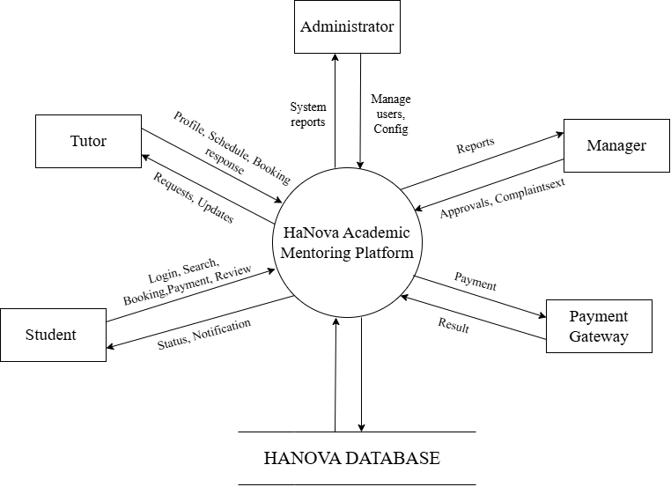
Figure 1: Flow diagram
The Flow Diagram above provides a high-level overview of the main interactions between external actors (Student, Tutor, Manager, Administrator, Payment Gateway) and an internal component (Database) with the HaNova Academic Mentoring Platform. This diagram helps visualize the flow of data and information exchange at the highest level, serving as a foundation for developing more detailed diagrams such as use case, sequence, and activity diagrams.

a. Main Component
- Central System (HaNova Academic Mentoring Platform): The platform handles all business operations including login, search, booking, payment, review, user management, system configuration, tutor profile approval, complaint handling, etc.
- External Actors:
  - Student: Learners who perform actions such as searching for tutors, booking lessons, making payments, submitting reviews and complaints.
  - Tutor: Instructors who manage their teaching schedules, confirm/reject booking requests, create study plans, and receive notifications.
  - Manager: Center managers responsible for approving tutor profiles, handling complaints, monitoring activities, and viewing reports.
  - Administrator: System administrators who manage user accounts, configure system settings, handle tutor violations.
  - Payment Gateway: Third-party payment processor (VNPay, MoMo, PayPal) that processes transactions and returns results.
- Internal Component:
  - Database: Stores all system data (user information, bookings, payments, reviews, complaints, reports, etc.).

b. Interaction Flow
- Student Flow:
  - Student performs actions: Login, Search, Booking-Payment, Review.
  - The system receives requests, reads/writes data from/to the Database, and processes business logic.
  - The system responds to the Student with: Status, Notification (booking status, confirmation notifications, class reminders, payment results).
- Tutor Flow:
  - Tutor performs actions: login, manage teaching schedules, view and confirm/reject booking requests from students, create study plans.
  - The system interacts with the Database to update available time slots and save study plans.
  - The system sends notifications to Tutors about new bookings, upcoming teaching schedules, and feedback from students.
- Manager Flow:
  - Manager performs actions: approve tutor profiles, handle complaints (Complaint text), monitor KPIs.
  - The system provides Reports (revenue, booking statistics, tutor performance) from the Database.
  - The system sends Approvals (tutor profile approvals) and Complaint text (complaint content from students) to the Manager for processing.
- Administrator Flow:
  - Administrator performs actions: Manage users, Config (manage student/tutor accounts, set service fees, configure system settings, handle tutor violations).
  - The system provides System reports (system-wide reports) from the Database.
  - The system records configuration changes and updates them in the Database.
- Payment Gateway and Database Flow:
  - When a Student makes a payment, the system sends a request to the Payment Gateway.
  - The Payment Gateway processes the transaction and sends a Payment Result (success/failure) back to the system.
  - The system updates the booking status and payment information in the Database.
  - The system sends payment result notifications to the Student.
- Database Interaction Flow:
  - All actors (Student, Tutor, Manager, Administrator) interact with the Database through the system to read/write data.
  - The Database stores: user information, bookings, payments, reviews, complaints, study plans, schedules, notifications, reports.

c. Data Flow Characteristics
The diagram reflects several important system characteristics:
- Centralized Processing: All interactions are handled through the core system, ensuring control and consistency.
- Bidirectional Communication: Each actor both sends requests and receives responses from the system.
- Real-time Updates: Changes in booking, payment, or scheduling are immediately reflected in the database and communicated to users.
- Integration with External Services: The system interacts with third-party services (payment gateway) to extend functionality.

2.8 USE CASE MODEL DESCRIPTION:
Use Case selection | Description
Use Case name | Approve Tutor Profile
Level | Sub-Functional level
Primary actor | Manager
Stakeholders and interest | - Tutor: wants profile to be approved and visible  - Manager: wants to control quality of tutors  - Student: wants to view verified tutor profiles
Pre - condition | Tutor profile is submitted and in "Pending Approval" status. Manager is logged in.
Post-condition | Tutor profile status is updated to "Approved". Profile becomes visible to students.
Main success scenario | 1 Manager views pending tutor profiles  2 Manager selects a profile  3 System displays tutor information  4 Manager reviews and clicks Approve  5 System updates status to Approved  6 Profile becomes visible
Alternative flow | 1 Manager selects Reject  2 Manager provides reason  3 System updates status to Rejected and notifies tutor
Specific requirement | System must update profile instantly  Notification must be sent to tutor
Table 1: Approve Tutor Profile

Use Case selection | Description
Use Case name | Manage Tutor Schedule
Level | Sub-Functional level
Primary actor | Tutor
Stakeholders and interest | Tutor: wants to manage availability  Student: wants to book available slots
Pre - condition | Tutor is logged in with approved account
Post-condition | Tutor's schedule is updated. Students can view/book slots.
Main success scenario | 1 Tutor opens schedule dashboard  2 Tutor adds new time slot  3 Tutor enters details  4 Tutor confirms  5 System saves and displays updated schedule
Alternative flow | Edit schedule  Delete schedule  Time conflict → system shows error
Specific requirement | No overlapping time slots allowed
Table 2: Manage Tutor Schedule

Use Case selection | Description
Use Case name | Manage Incoming Booking Requests
Level | Sub-Functional level
Primary actor | Tutor
Stakeholders and interest | Tutor: wants to accept/reject requests  Student: wants booking confirmation
Pre - condition | Tutor logged in. Student has submitted booking request.
Post-condition | Booking status updated to Accepted or Rejected. Schedule updated if accepted. Student notified.
Main success scenario | 1 Tutor opens booking requests  2 Tutor selects a request  3 System displays details  4 Tutor chooses Accept  5 System updates status  6 System adds to schedule
Alternative flow | Reject request → notify student  Booking invalid → error
Specific requirement | System must validate availability before accepting
Table 3: Manage Incoming Booking Requests

Use Case selection | Description
Use Case name | Reschedule / Cancel Lesson
Level | User-goal level
Primary actor | Student, Tutor
Stakeholders and interest | - Student: wants to reschedule or cancel lessons when schedule changes.  - Tutor: wants to manage teaching schedule flexibly.  - System/Admin: ensures schedule consistency and notification delivery.
Pre - condition | A lesson has already been booked in the system and the user (Student or Tutor) is logged in successfully.
Post-condition | - The lesson is successfully rescheduled to a new time OR cancelled.  - Both Student and Tutor receive notifications about the update.
Main success scenario | 1. Student/Tutor logs into the system.  2. User views and selects a booked lesson.  3. User chooses Reschedule or Cancel.  4. If Reschedule, user selects a new time slot.  5. System checks availability and updates the schedule if valid.  6. System sends notification to both Student and Tutor.
Alternative flow | 1. The system detects that the selected time slot is not available.  2. The system asks the user to select another time slot.
Specific requirement | - System must check time slot availability before rescheduling.  - System must send notifications after reschedule/cancel action.  - Response time should be fast (≈ ≤ 3 seconds theo NFR).
Table 4: Reschedule / Cancel Lesson
Use Case selection | Description
Use Case name | Process Lesson Payment
Level | User Goal level
Primary actor | Student
Stakeholders and interest | - Student: wants to complete payment to confirm booking.  - Tutor: wants assurance that the lesson is paid.  - Manager: ensures accurate transaction recording and financial tracking.
Pre - condition | Student has already booked a lesson and logged into the system.
Post-condition | The payment is successfully processed and recorded, the booking status is updated to “Paid”.The student receives a payment confirmation notification.
Main success scenario | 1. Student logs into the system.  2. Student views and selects a lesson requiring payment.  3. Student chooses “Pay Lesson Fee”.  4. System displays payment details.  5. Student selects a payment method and confirms payment.  6. System processes the payment and updates booking status to “Paid”.  7. System sends a confirmation notification.
Alternative flow | - Time Slot Not Available: System asks user to choose another slot.  - Cancel Lesson: System cancels lesson and notifies users.
Specific requirement | - System must ensure secure payment (HTTPS, data protection).  - Payment processing must be accurate and reliable.  - Response time ≤ 3 seconds
Table 5: Process Lesson Payment

Use Case selection | Description
Use Case name | Receive Booking and Class Notifications
Level | User - goal level
Primary actor | Student, Tutor
Stakeholders and interest | - Student: wants updates about bookings and classes.  - Tutor: wants to stay informed about schedule changes.  - System/Admin: ensures reliable notification delivery.
Pre - condition | The user has a registered account and is logged in or has enabled notifications.  A booking-related event occurs in the system.
Post-condition | The user receives a notification, which is stored in history and informs them about the booking status.
Main success scenario | 1. A booking event occurs (create/update/cancel).  2. System processes and records the event.  3. System generates a notification.  4. System sends notification to Student/Tutor.  5. Notification appears in dashboard/notification center.  6. User views notification and accesses booking details.
Alternative flow | 1. Reminder: System sends class reminder notifications.  2. Cancellation: System notifies users of lesson cancellation.  3. Schedule Change: System notifies users of schedule updates.
Specific requirement | - System must deliver notifications reliably and in real-time.  - Notification data must be stored for later access.
Table 6: Receive Booking and Class Notifications

Use Case selection | Description
Use Case name | Generate Study Plan
Level | User Goal
Primary actor | Tutor
Stakeholders and interest | Tutor: Wants to provide a structured roadmap for students.  Student: Wants a clear path to follow for academic progress.  Manager: Wants to ensure teaching quality and consistency.
Pre - condition | 1. Tutor is logged in with an approved, active account.  2. At least one confirmed booking exists between the Tutor and target Student.
Post-condition | 1. A study plan is saved and linked to the Tutor, Student, and booking.  2. Student receives a notification about the shared plan.
Main success scenario | 1. Tutor selects "Student Management" or "Group Management".  2. Tutor chooses a specific student and clicks "Create Study Plan".  3. System displays the plan creation form.  4. Tutor enters Plan Name, Objectives, and Session Schedule.  5. Tutor previews and clicks "Submit".  6. System saves the plan and notifies the student.
Alternative flow | System proposes a draft based on learning history; Tutor reviews and confirms.
Specific requirement | The system must support file attachments (Materials) up to 10MB per session

Table 7: Generate Study Plan

Use Case selection | Description
Use Case name | Manage Study Group
Level | User Goal
Primary actor | Student
Stakeholders and interest | Student: Wants to collaborate with others and share costs.  Tutor: Wants to manage groups for collective sessions.
Pre - condition | 1. Student is logged into the system.  2. Student must be a member of the group to perform updates or leave.
Post-condition | 1. Group information is successfully created, updated, or removed.  2. Database is updated with the latest member list.
Main success scenario | 1. Student navigates to "My Study Groups".  2. System displays the list of groups associated with the student  3. Student selects an action (Create, View, Update, Leave, or Delete).  4. Student modifies group details as required.  5. Student confirms the action.  6. System validates data and saves changes.
Alternative flow | If student leaves and is the last member, system deletes the group record.
Specific requirement | Member contact information must be visible only to confirmed group members.
Table 8: Manage Study Group

Use Case selection | Description
Use Case name | Manage Personal Study Schedule
Level | User Goal
Primary actor | Student
Stakeholders and interest | -Student: Wants to organize their time and avoid learning conflicts.  Tutor: Wants to ensure student availability for booked lessons.
Pre - condition | 1. Student is logged into HaNova.  2. Student has at least one confirmed booking with a tutor
Post-condition | Personal schedule is saved and updated in the system database
Main success scenario | 1. Student selects "My Schedule" from the dashboard.  2. System retrieves data and displays the calendar (Day/Week/Month).  3. Student clicks an empty slot and selects "Add Self-Study".  4. Student enters subject, duration, and notes.  5. System validates no conflict with booked lessons.  6.. System saves and refreshes the calendar.
Alternative flow | Student selects an existing self-study session to modify or remove.
Specific requirement | Calendar must support real-time sync with confirmed tutor lesson updates.
Table 9: Manage Personal Study Schedule

Use Case selection | Description
Use Case name | Submit Tutor Review
Level | Sub-Functional level
Primary actor | Student
Stakeholders and interest | Student: wants to provide feedback about tutor quality.  Tutor: wants to receive fair and accurate reviews to improve performance.  System/Admin: ensures only verified reviews are accepted and displayed correctly.
Pre - condition | Student is logged in.  Student has completed a lesson (status = Completed).  Lesson was completed within the last 30 days.  Student has not submitted a review for this lesson.
Post-condition | Review is stored in the system.  Tutor’s rating is updated.  Tutor profile displays the new review.
Main success scenario | 1. Student opens “My Completed Lessons”.  2. Student selects “Write Review”.  3. System displays review form.  4. Student enters rating and comment.  5. Student submits the review.  6. System validates and saves the review.  7. System updates tutor rating and shows success message.
Alternative flow | 1. Student accesses review via notification/email link.  2. System redirects to login if needed.  3. Student is redirected to review form.  4. Flow continues as normal.
Specific requirement | • Only completed lessons can be reviewed.  • Each lesson allows only one review per student.  • Rating (1–5) is required.  • Comment must be between 10–500 characters.
Table 10: Submit Tutor Review

Use Case selection | Description
Use Case name | Review Tutor Performance
Level | Sub-Functional level
Primary actor | Manager
Stakeholders and interest | Manager: wants to evaluate tutor performance and make management decisions.  Tutor: wants fair evaluation based on performance data.  System/Admin: ensures accurate calculation and display of tutor performance metrics.
Pre - condition | Manager is logged into the system.  Tutor accounts exist in the database.  Tutor activity data (bookings, ratings, feedback) is available.
Post-condition | Tutor performance data is displayed.  Manager gains insights about tutor performance.  System logs the performance review activity.
Main success scenario | 1. Manager logs into the system.  2. Manager accesses the dashboard.  3. Manager selects Tutor Management.  4. System displays list of tutors.  5. Manager selects a tutor.  6. System retrieves tutor data from database.  7. System calculates performance metrics (bookings, rating, acceptance rate, cancellation rate).  8. System displays performance report.  9. Manager reviews tutor performance.  10. System displays student feedback.  11. Manager may view charts/statistics.  12. Manager completes the review.
Alternative flow | 1. Manager filters performance by time period.  2. System updates data based on selected range.  3. Manager reviews updated results.
Specific requirement | • System shall calculate performance metrics accurately.  • System shall support filtering by time period.  • System shall support comparison between tutors.  • System shall display data within acceptable response time.
Table 11: Review Tutor Performance

Use Case selection | Description
Use Case name | Submit Complaint
Level | Sub-Functional level
Primary actor | Student
Stakeholders and interest | Student: wants to report issues related to tutor quality, attitude, or schedule.  Tutor: may be subject to complaints and evaluation.  Manager/Admin: wants to receive and handle complaints to ensure service quality.
Pre - condition | Student is logged into the system.  Student has completed at least one lesson with a tutor.  The lesson related to the complaint exists in the system.
Post-condition | Complaint is recorded with status "Pending".  Notification is sent to Manager/Admin.  Student receives confirmation of submission.
Main success scenario | 1. Student accesses "Lesson History" or "Tutor Profile".  2. Student selects "Submit Complaint".  3. System displays complaint form.  4. Student selects complaint type and enters description.  5. Student optionally uploads attachment.  6. Student submits complaint.  7. System validates input data.  8. System stores complaint with all related information.  9. System sends confirmation to student.  10. System notifies Manager/Admin.
Alternative flow | 1. Student selects anonymous complaint option.  2. System informs about anonymity.  3. Student submits complaint.  4. System saves complaint as anonymous.
Specific requirement | • Complaint must be associated with a valid lesson.  • System shall support optional file attachment.  • System shall support anonymous complaint submission.  • System shall notify Manager/Admin immediately after submission.
Table 12: Submit Complaint

2.9.1 USE CASE DIAGRAM
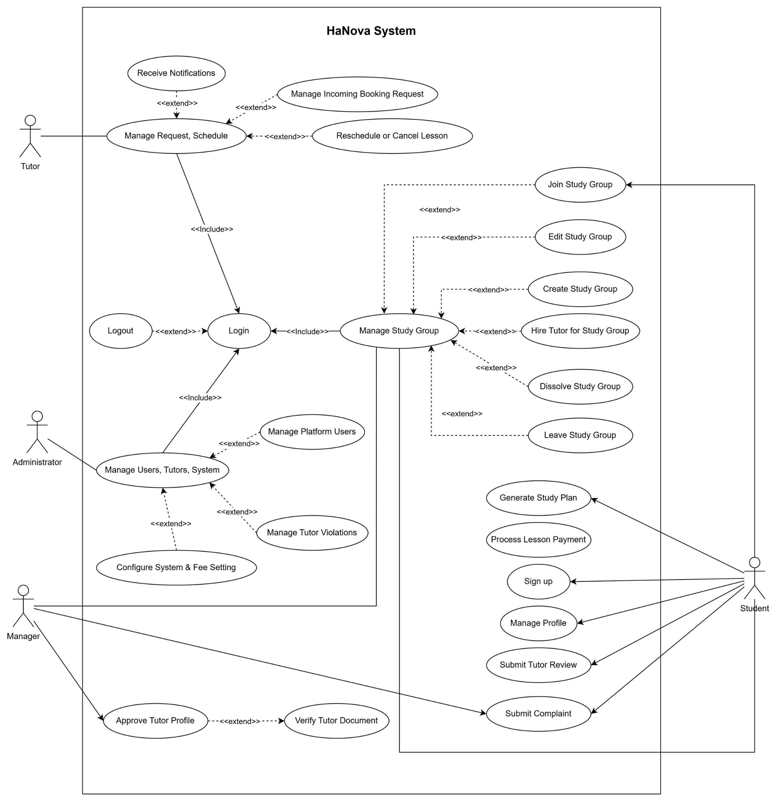
Figure 2: Use case diagram
This diagram presents a high-level overview of user interactions within the HaNova Tutoring Platform. It highlights four key user roles: Student, Tutor, Manager, and Administrator. Each role is associated with specific system functionalities, reflecting their unique responsibilities and access privileges.

Student
Students use the system to support their learning and booking activities. Their main functionalities include:
- Registering and logging into the system
- Searching and booking tutors
- Managing personal profiles and study schedules
- Creating or joining study groups
- Requesting lessons and rescheduling/canceling bookings
- Making payments for lessons or group sessions
- Receiving notifications about bookings and classes
- Submitting tutor reviews and complaints

Tutor
Tutors interact with the system to manage their teaching activities and student requests. Their main functionalities include:
- Managing tutor profile and availability schedule
- Receiving and responding to booking requests
- Conducting lessons (online/offline)
- Managing study groups (join/teach group)
- Generating study plans for students or groups
- Receiving payments for completed lessons
- Receiving notifications about bookings and classes

Manager
Managers oversee system operations and ensure service quality. Their main functionalities include:
- Approving tutor profiles
- Verifying tutor documents
- Managing study groups
- Handling user complaints
- Monitoring system activities

Administrator
Administrators are responsible for system-level management and configuration. Their main functionalities include:
- Managing platform users (students, tutors)
- Managing tutor violations and disciplinary actions
- Configuring system settings and service fees
- Maintaining overall system performance

Association (Direct Relationship)
Association is a direct relationship between an actor (user) and a use case (functionality), indicating that the actor can perform or trigger the corresponding action. In the HaNova system, associations are represented by solid lines:
- Students are associated with Sign up, Login, Manage Profile, Submit Learning Goal, Search Tutor, Book Lesson, Manage Personal Schedule, Process Lesson Payment, Receive Booking & Class Notifications, Manage Study Group, Generate Study Plan, Submit Verified Tutor Review, and Submit complaint.
- Tutors are associated with Login, Manage Profile, Manage Incoming Booking Request, Reschedule or Cancel a Booked Lesson, Process Lesson Payment, Receive Booking & Class Notifications, Manage Study Group, Generate Study Plan, Submit Verified Tutor Review, and Monitor booking & Lesson Activity.
- Managers are associated with Submit complaint, Approve Tutor Profile, Manage Study Group, and View Revenue & Financial Reports.
- Administrators are associated with Login, Manage Platform Users, Manage Tutor Violations, Configure System & Fee Settings, and Manage Group Behavior.

«include» (Inclusion – Mandatory Execution)
The «include» relationship indicates that a primary use case always includes one or more sub-use cases during its execution. Whenever the main use case is executed, the system is required to execute the included use case(s) as part of the process. This relationship is represented using dashed arrows labeled «include», pointing from the primary use case to the included use case. In the HaNova system:
- When a user performs "Login", the system includes access to other core functionalities such as "Manage Profile", "Manage Personal Schedule", "Manage Incoming Booking Request", and "Process Lesson Payment", enabling full access after successful authentication.
- The inclusion of shared logic helps make the diagram more concise, readable, and maintainable by ensuring that mandatory steps are always performed.

«extend» (Extension – Optional Execution)
The «extend» relationship describes a scenario where an optional (or additional) use case may be triggered from a main use case, but it is not required to occur every time. This is useful to illustrate system behaviors that only happen under specific conditions or upon user request. In the diagram, an «extend» is represented by dashed arrows labeled «extend», pointing from the extending use case to the extended (base) use case. For example:
- "Login" can be extended with the optional action of "Log out".
- "Manage Profile" can be extended with additional actions such as "View Profile", "Add Information", or "Edit Profile".
- "Search Tutor" is extended by "View List Tutor", which only occurs when the student chooses to browse the full list.
- "Book Lesson" is extended by "Check Tutor Availability" to verify the schedule before finalizing.
- "Reschedule or Cancel a Booked Lesson" is extended by "Handle Refund", which only occurs under specific cancellation policies.
- "Submit Verified Tutor Review" is extended by "Verify Completed Lesson" to ensure the authenticity of the feedback.
- "Approve Tutor Profile" is extended by "Verify Tutor Document", triggered when the Manager needs to validate specific credentials.
- "Submit complaint" can be extended to the Manager for further investigation and resolution.
2.9.2 CLASS DIAGRAM
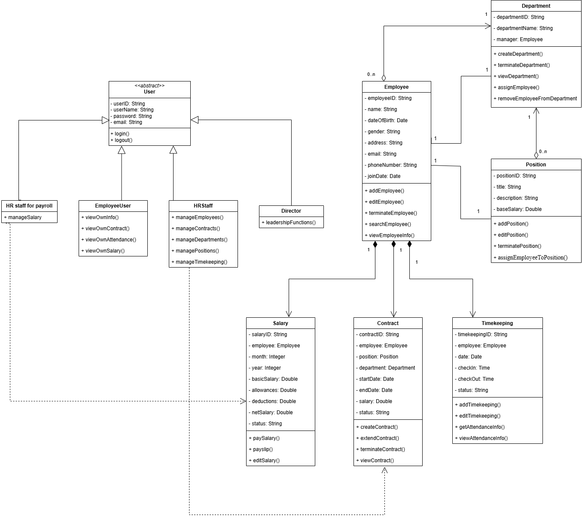Figure 3: Class diagram

The class diagram illustrates the object-oriented structure of the HaNova Tutoring Platform, detailing how different entities (classes) are defined and how they interact with one another. It provides a blueprint of the system’s architecture by representing the attributes, methods, and relationships between classes.
Key components typically include:

User Class (Abstract)
The User class serves as the base class for all system users. It contains common attributes such as userID, username, password, and email, and defines shared methods including login() and logout(). This class is extended by other roles in the system, enabling reuse of common functionalities while allowing role-specific extensions.

Student Class
The Student class represents learners who use the platform to find tutors and participate in study activities. It provides functionalities such as searching for tutors, booking lessons, joining or creating study groups, making payments, and submitting reviews, thereby supporting the main user interactions within the system.

Tutor Class
The Tutor class represents instructors who provide teaching services. It includes attributes such as expertise and hourlyRate, and supports key functionalities such as managing schedules, accepting bookings, conducting lessons, and creating study plans to support student learning.

Manager Class
The Manager class is responsible for moderation and system supervision. It provides functionalities such as approving and verifying tutors, managing study groups, and handling complaints to ensure service quality and system reliability.

Admin Class
The Admin class handles system-level administration. Its responsibilities include managing users, handling violations, and configuring system settings to maintain overall system control and stability.
- Booking Class
The Booking class represents a tutoring session between a student and a tutor. It includes attributes such as bookingID, date, and status, and supports operations such as creating, canceling, and rescheduling bookings.

Payment Class
The Payment class handles financial transactions for lessons or study groups. It contains attributes such as paymentID, amount, status, and method, and provides functionality for processing payments within the system.

StudyGroup Class
The StudyGroup class represents a group of students learning together. It includes attributes such as groupID, name, subject, maxMembers, schedule, mode, and price, and supports operations such as creating, editing, and dissolving groups.

GroupMember Class
The GroupMember class acts as a linking entity between Student and StudyGroup. It stores additional information such as role and joinDate, helping to manage membership relationships within study groups.

Review Class
The Review class represents feedback provided by students for tutors. It includes attributes such as reviewID, rating, and comment, supporting service evaluation and quality improvement.

Complaint Class
The Complaint class represents issues or complaints submitted by users. It contains attributes such as complaintID, content, and status, allowing the system to track and resolve user concerns.

StudyPlan Class
The StudyPlan class represents study plans created by tutors. It includes attributes such as planID and content, supporting structured learning for students.

Notification Class
The Notification class handles system notifications. It contains attributes such as notificationID, message, and date, enabling communication between the system and users.

1. Inheritance (Generalization)
Inheritance is represented by a hollow arrowhead pointing upward, indicating that a subclass inherits attributes and methods from a superclass.
- The following classes inherit from the abstract class User:
- Student
- Tutor
- Manager
- Admin
  - The User class provides common attributes such as userID, username, password, and email.
It also defines shared methods like login() and logout().
  - Each subclass extends the base behavior with its own functions:
    - Student: searchTutor(), bookLesson(), joinGroup(), createGroup(), makePayment(), submitReview()
    - Tutor: manageSchedule(), acceptBooking(), teachLesson(), createStudyPlan()
    - Manager: approveTutor(), verifyTutor(), manageGroups(), handleComplaint()
    - Admin: manageUsers(), manageViolations(), configureSystem()

2. Association (Class Relationships)
Associations describe the relationships between objects, represented by solid lines connecting classes, often with multiplicity indicators.
a. Student – Booking
- 1 to many (1..n) relationship
- One Student can create multiple Booking records.
Each Booking is linked to one specific Student.
b. Tutor – Booking
- 1 to many (1..n) relationship
- One Tutor can handle multiple Booking records.
Each Booking belongs to only one Tutor.

c. Booking – Payment
- 1 to 1 (1..1) relationship
- Each Booking has one Payment.
Each Payment is associated with one Booking.
d. Student – StudyGroup
- many to many (0..n) relationship
- A Student can join multiple StudyGroups.
Each StudyGroup can contain multiple Students.
e. StudyGroup – GroupMember
- 1 to many (1..n) relationship
- A StudyGroup contains multiple GroupMember instances.
Each GroupMember belongs to one StudyGroup.
f. Tutor – StudyGroup
- 1 to many (0..n) relationship
- A Tutor can teach multiple StudyGroups.
Each StudyGroup may be associated with one Tutor.
g. Student – Review
- 1 to many (1..n) relationship
- A Student can submit multiple Reviews.
Each Review is linked to one Tutor.
h. User – Complaint
- 1 to many (0..n) relationship
- A User can submit multiple Complaints.
Each Complaint belongs to one User.
i. Tutor – StudyPlan
- 1 to many (1..n) relationship
- A Tutor can create multiple StudyPlans.
Each StudyPlan belongs to one Tutor.

j. User – Notification
- 1 to many (0..n) relationship
- A User can receive multiple Notifications.

3. Object References (Composition/Direct Linkage)
Some classes directly reference objects of other classes rather than just IDs:
- Booking contains student: Student and tutor: Tutor objects
- Payment contains booking: Booking object
- GroupMember includes student: Student and studyGroup: StudyGroup
- StudyPlan contains tutor: Tutor object
This promotes better integration and encapsulation between components of the system.

4. Multiplicity
Multiplicity defines how many instances of one class are related to instances of another class:
- 1 – exactly one (required)
- 0..n – zero or many (optional and multiple)
- 1..n – one or more

2.9.3 SEQUENTIAL DIAGRAM
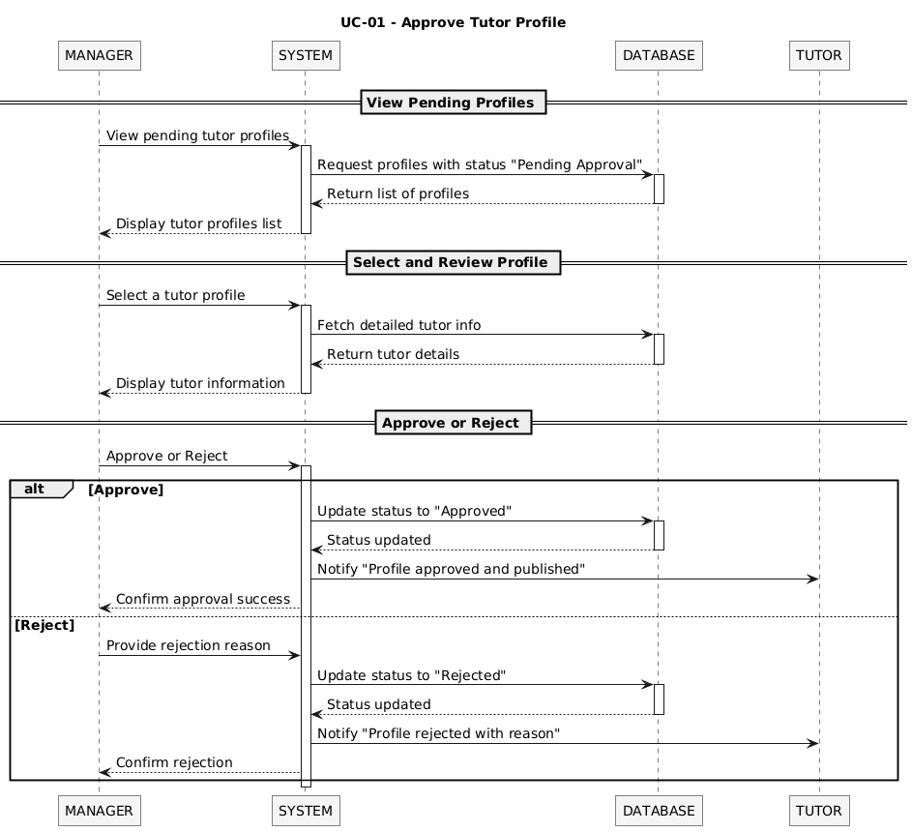
Figure 4(a): Approve Tutor Profile
- Actors: Manager, System, Database, Tutor
- Main Flow:

View pending tutor profiles:
- Manager logs into the system and navigates to the Tutor Management section.
  - The System sends a request to the Database to retrieve profiles with status "Pending Approval".
- System retrieves and displays the list of pending profiles from the database.

Select and review profile:
- The Manager selects a specific tutor profile.
- The System displays the full profile information to the Manager.
- Manager reviews the information and clicks "Approve".
- System updates the tutor's profile status to "Approved" in the database and sends an approval notification to the Tutor.
- Tutor's profile becomes visible to students on the platform.
- Alternative Flow:

Reject profile:
- The Manager provides a rejection reason.
- The System updates the profile status to "Rejected" in the Database.
- The Database confirms the update.
- The System notifies the Tutor: "Profile rejected with reason".
- The System confirms the rejection to the Manager.

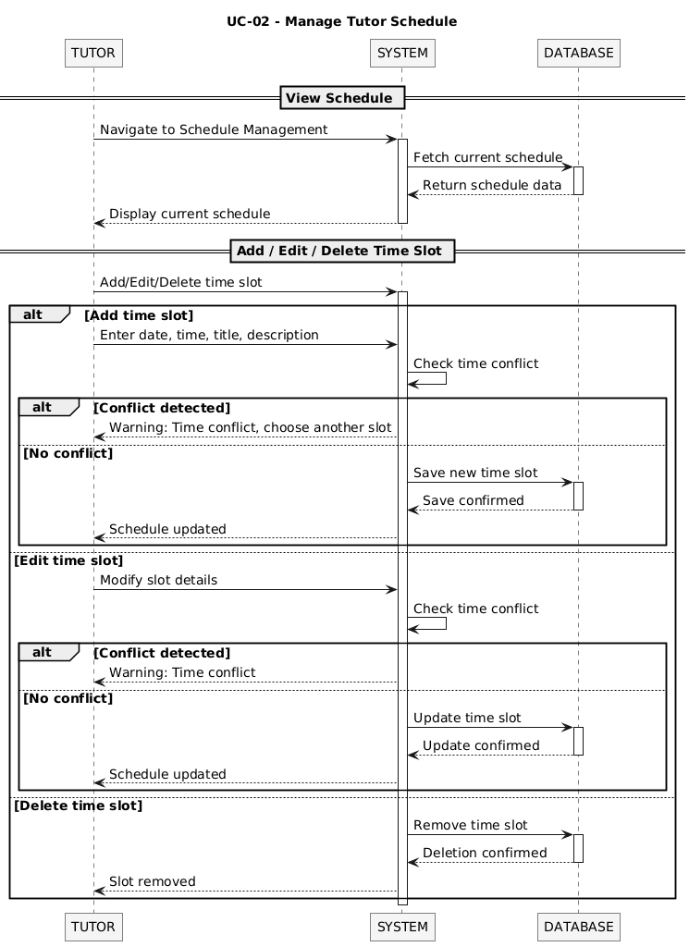
Figure 4(b): Manage Tutor Schedule
- Actors: System, Database, Tutor
- Main Flow:
- Tutor logs into the system and accesses the Schedule Dashboard.
- System retrieves and displays the current schedule from the database.
- Tutor clicks "Add New Time Slot" and enters the date, start time, end time, and subject.
- System validates the input for formatting and checks for time conflicts with existing slots.
- If no conflict is found, the system saves the new slot to the database and refreshes the schedule display.
- Tutor receives a success confirmation message.
- Alternative Flow:

Edit time slot:
- The Tutor modifies the slot details.
- The System checks for time conflicts.
- If conflict detected:
- The System shows a warning: "Time conflict".
- If no conflict:
- The System updates the time slot in the Database.
- The Database confirms the update.
- The System updates and displays the schedule.

Delete time slot:
- The System removes the selected time slot from the Database.
- The Database confirms deletion.
- The System updates the schedule and notifies the Tutor.

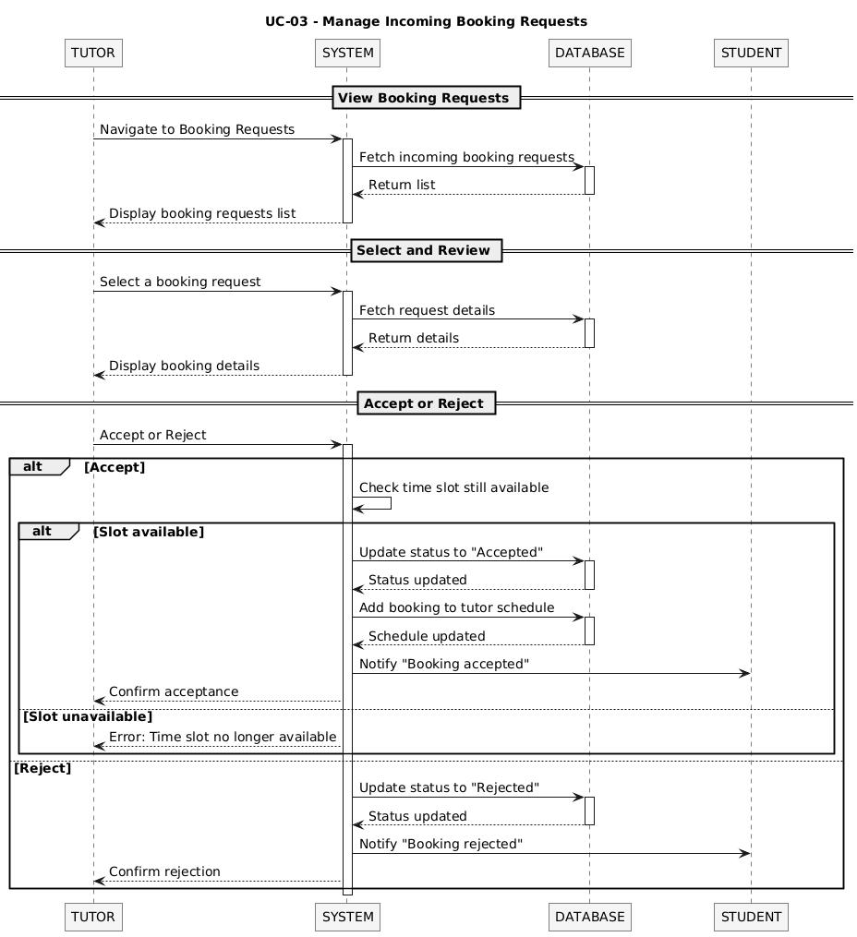
Figure 4(c): Manage Incoming Booking Requests
- Actors: Tutor, System, Database, Student
- Main Flow:
- Tutor logs in and opens the "Booking Requests" section.
- System retrieves and displays all pending booking requests from the database.
- Tutor selects a specific booking request to review.
- System displays full booking details including student name, subject, time slot, and lesson type.
- Tutor clicks "Accept".
- System validates tutor availability for the requested time slot.
- System updates the booking status to "Confirmed" in the database.
- System locks the time slot in the Tutor's schedule.
- System sends a confirmation notification to the Student.
- Alternative Flow:
  - Reject Request:
- The System updates the request status to "Rejected" in the Database.
- The Database confirms the update.
- The System notifies the Student: "Booking rejected".
- The System confirms the rejection to the Tutor.

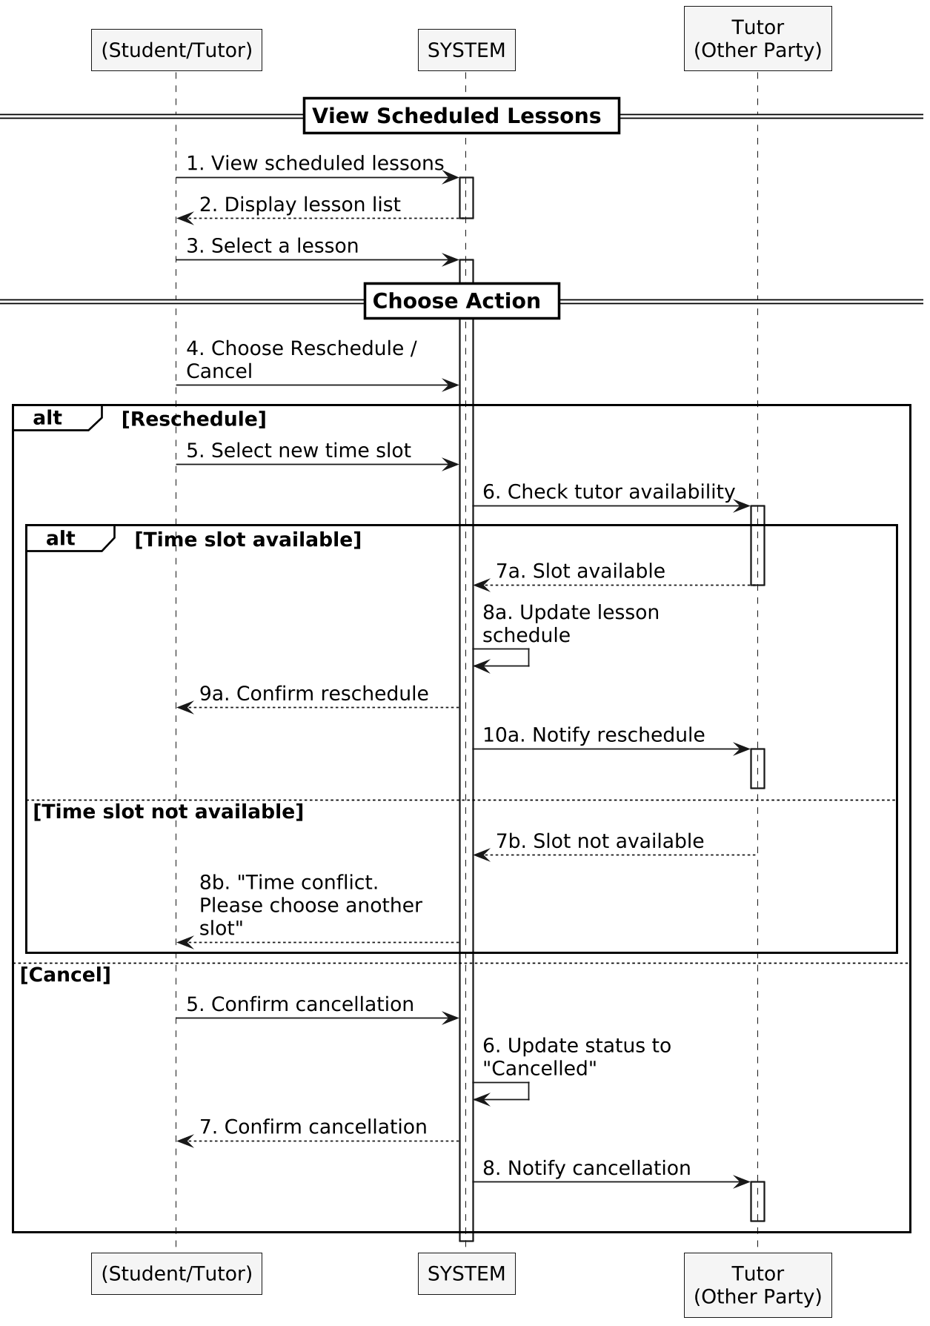
Figure 4(d): Reschedule / Cancel Lesson
- Actors: Student/Tutor, System, Tutor (Other Party)
- Main Flow(Reschedule):
- Student or Tutor logs into the system and navigates to "My Schedule" or "Lesson History".
- User selects an existing confirmed booking.
- System displays booking details and available actions.
- User selects "Reschedule" and chooses a new available time slot.
- System checks availability of the new slot for both Student and Tutor.
- If valid, System updates the booking with the new time in the database.
- System sends reschedule notification to both Student and Tutor.
- Main Flow (Cancellation):
- User selects a confirmed booking and clicks "Cancel Lesson".
- System checks the cancellation policy (e.g., time remaining before lesson).
- System updates booking status to "Cancelled" and triggers the refund process if applicable.
- System sends cancellation notifications to both parties.
- Alternative Flow:
- New Slot Not Available: System rejects the reschedule request and displays an error. User is prompted to select a different time slot.
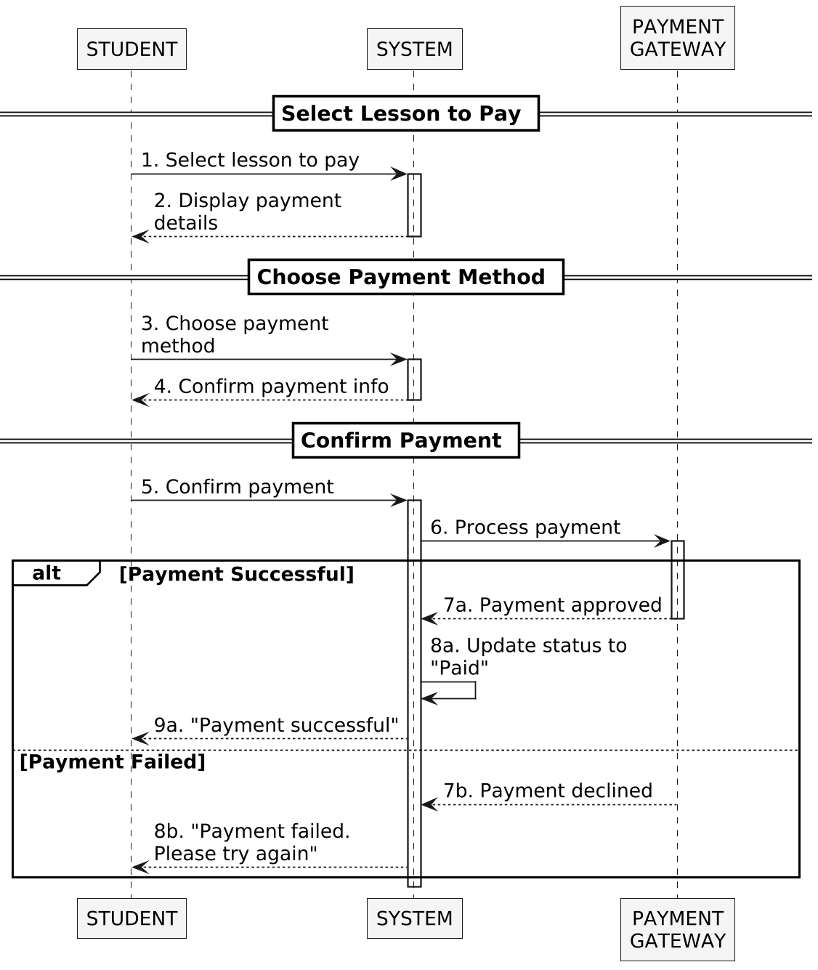

Figure 4(e): Process Lesson Payment

- Actors: Student, System, Payment Gateway
- Main Flow:
- Student logs into the system and navigates to the booking requiring payment.
- System displays payment summary including lesson details, tutor name, and total amount.
- Student selects a payment method (VNPay, MoMo, or PayPal) and clicks "Pay Now".
- System generates a payment request and forwards it to the selected payment gateway.
- Payment gateway processes the transaction and returns a success response.
- System updates the booking status to "Paid" in the database.
- System records the payment transaction in the Payment table.
- System sends a payment confirmation notification to both Student and Tutor.
- Alternative Flow:
  - Payment Failed:
- If the gateway returns a failure response (e.g., insufficient funds, network error), System displays an error message.
- The System notifies the Student: "Payment failed. Please try again".

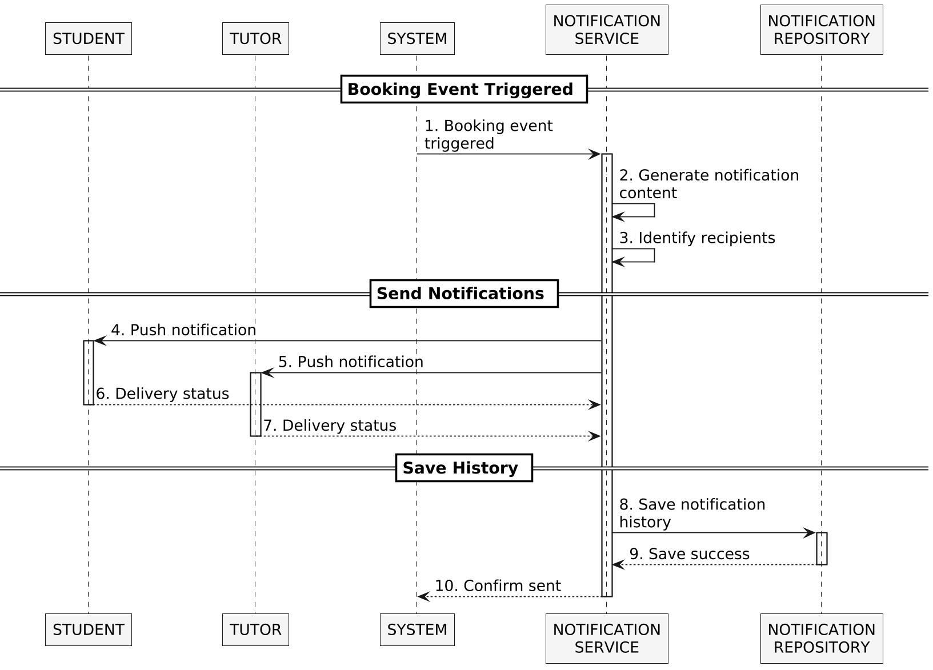

Figure 4(f): Receive Booking & Class Notifications
- Actors: Student, Tutor, System, Notification Service, Notification Repository
- Main Flow:
- A booking-related event occurs (e.g., booking created, payment confirmed, lesson rescheduled, cancelled).
- System automatically processes and records the event in the database.
- System triggers the Notification Service with the event details.
- Notification Service generates a corresponding notification message with relevant details (event type, time, involved parties).
- Notification Service identifies the relevant recipients and sends the notification to the appropriate user(s) — Student, Tutor, or both.
- Notification Service saves the notification history to the Notification Repository.
- Notification appears in the user's dashboard Notification Center.
- User opens the notification and is directed to the related booking details.
- Alternative Flow:
  - Class Reminder:
- System automatically sends a reminder notification to both Student and Tutor a set time before the lesson (e.g., 24 hours and 1 hour before).
  - Cancellation Notification:
- When a lesson is cancelled, System immediately notifies both parties and includes refund information if applicable.
  - Schedule Change Notification:
- Any modification to a confirmed lesson (reschedule, tutor profile update) triggers an automatic notification.

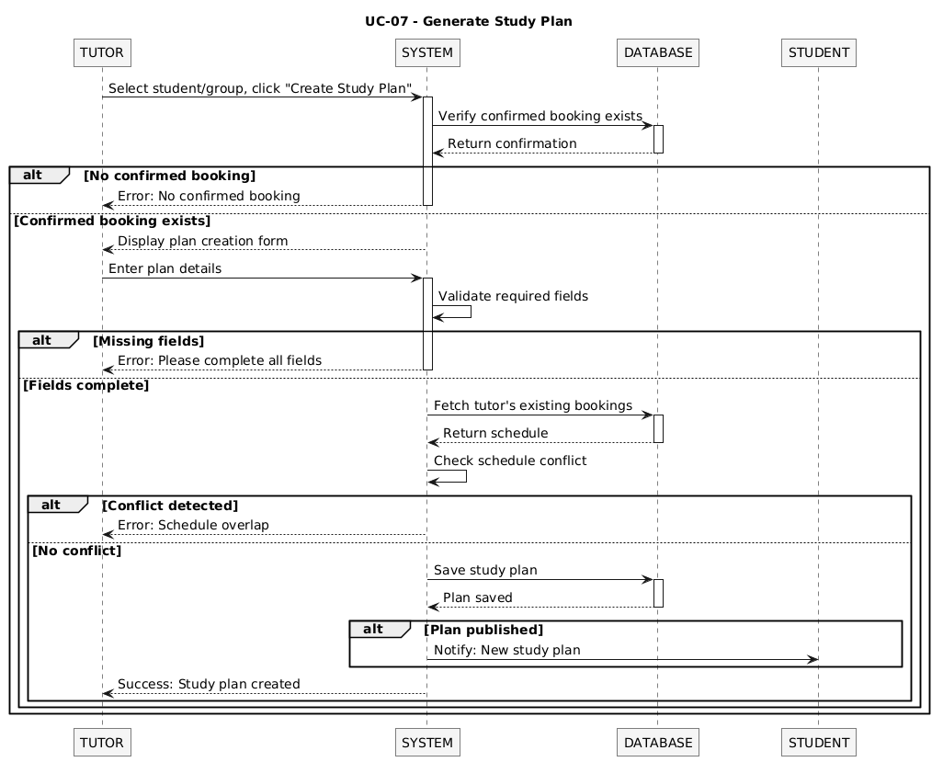
Figure 4(g): Generate Study Plan
- Actors: Tutor, System, Database, Student
- Main Flow:
- Tutor logs in and navigates to "Student Management" or "Group Management".
- Tutor selects a specific student (or group) with at least one confirmed booking.
- Tutor clicks "Create Study Plan".
- System displays the Study Plan creation form.
- Tutor enters Plan Name, Learning Objectives, Session Schedule, and optionally attaches learning materials (up to 10MB per session).
- Tutor previews the plan and clicks "Submit".
- System validates all required fields and checks for schedule conflicts.
- System saves the Study Plan to the database, linked to the Tutor, Student, and associated booking.
- System sends a notification to the Student informing them the plan is available on their dashboard.
- Alternative Flow:
- Draft Plan: System may propose a draft study plan based on the student's learning history. The Tutor reviews and confirms or modifies before submitting.
- Validation Error: If required fields are missing or a schedule conflict exists, System displays an error message and prompts the Tutor to correct the input.

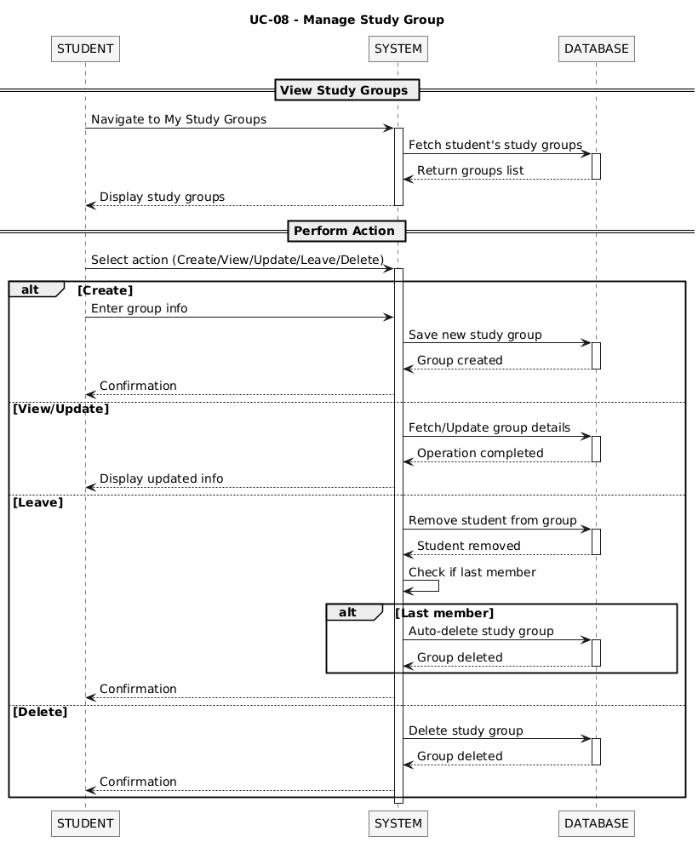
Figure 4(h): Manage Study Group
- Actors: Student, System, Database, Tutor
- Main Flow:
- Student logs in and navigates to "My Study Groups".
- System retrieves and displays all study groups associated with the Student.
- Student selects an action: Create, View, Update, Leave, or Delete.
- Create Group: Student enters group details (name, subject, schedule, max members, price, mode). System validates data and creates the group record in the database.
- Update Group: Student modifies group details and confirms. System validates and saves the changes.
- Leave Group: Student confirms departure. System removes the Student from the group's member list.
- Delete Group: If the Student is the group owner and the last member, System deletes the group record entirely.
- Alternative Flow:
  - Join Group:
- Join Existing Group: Student browses available groups, selects one, and submits a join request. System validates the request (group capacity, subject match) and adds the Student to the member list.
  - Leave Group:
- If Student leaves and is the last member: System automatically dissolves the group and deletes the associated record.

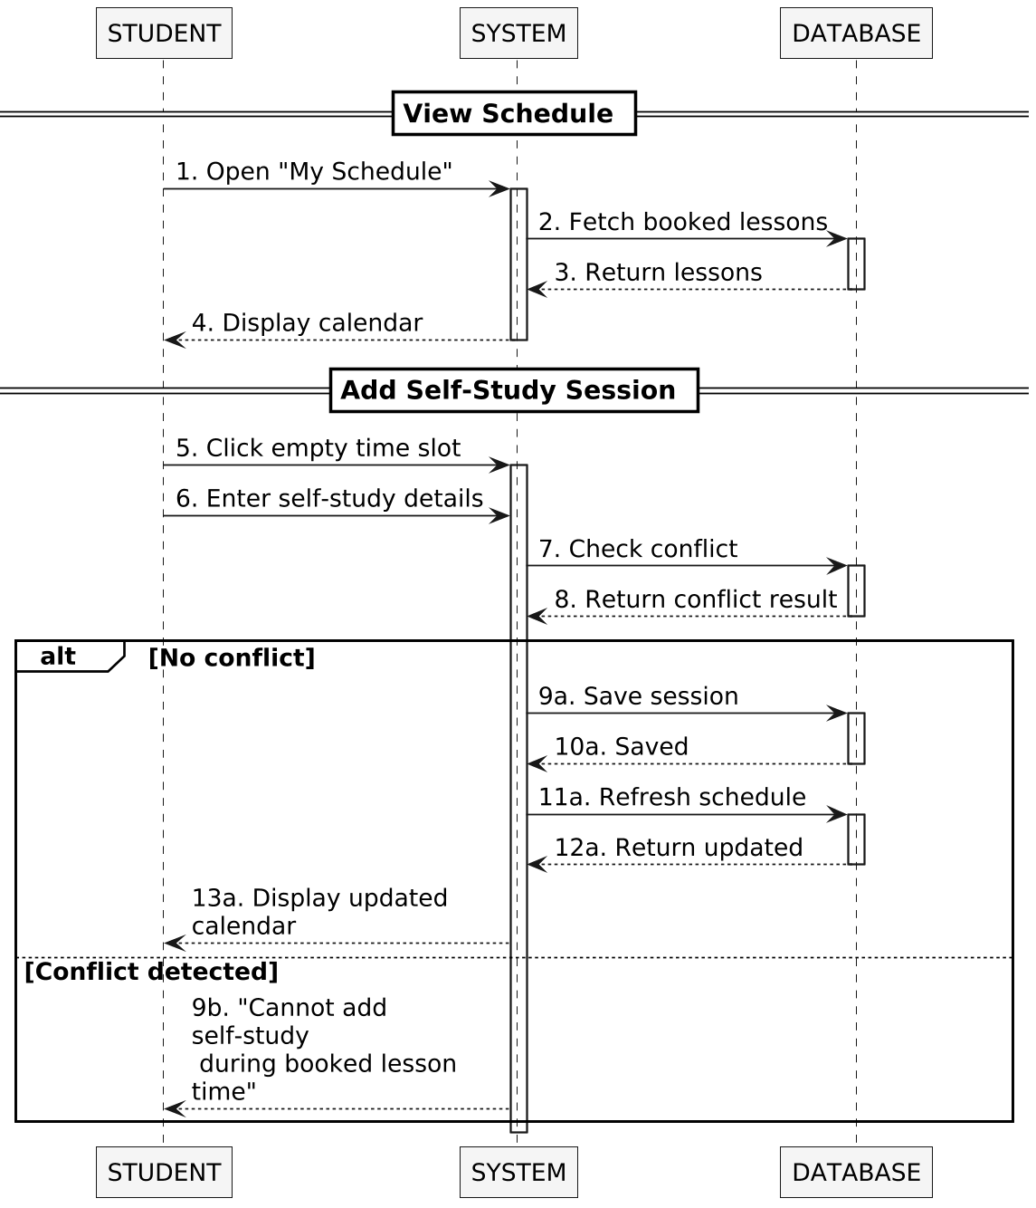
Figure 4(i): Manage Personal Study Schedule
- Actors: Student, System, Database

Main Flow:
- Student opens “My Schedule”.
- System retrieves booked lessons from the Database and returns the data.
- System displays the schedule (calendar view) to the Student.
- Student selects an empty time slot.
- Student enters self-study session details.
- System checks for conflicts with existing booked lessons in the Database.
- No Conflict:
+ System saves the self-study session into the Database.
+ System refreshes the schedule data.
+ Updated schedule is returned and displayed to the Student.
- Alternative Flow:
  - Conflict Detected:
- If the selected time slot overlaps with an existing booked lesson, the system does not allow the session to be created.
- A message is returned to the Student: “Cannot add self-study during booked lesson time.”

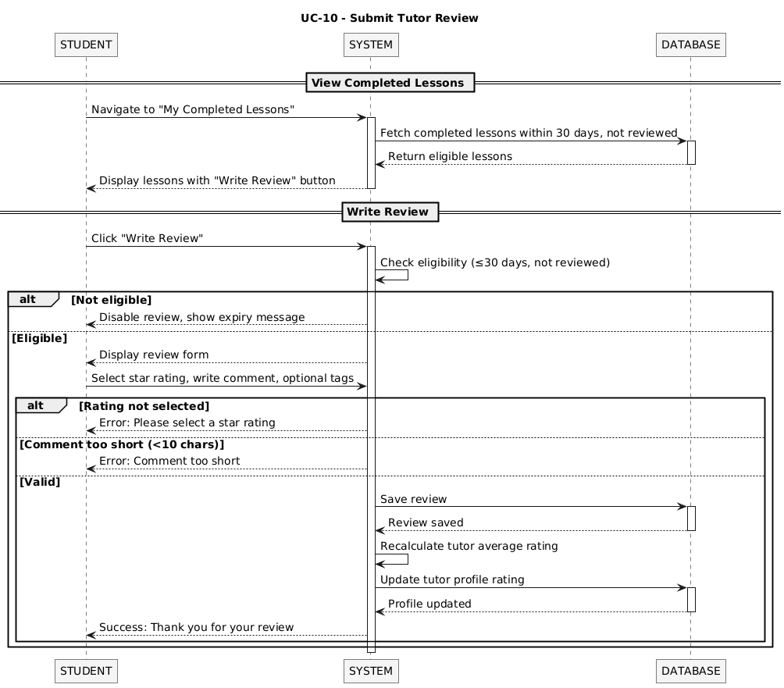
Figure 4(j): Submit Tutor Review

- Actors: Student, System, Database

Main Flow:
- Student navigates to “My Completed Lessons”.
- System retrieves completed lessons within 30 days that have not been reviewed from the Database.
- System displays the lesson list with the “Write Review” option.
- Student clicks “Write Review”.
- System checks eligibility (lesson within 30 days and not yet reviewed).
- Eligible:
+ System displays the review form.
+ Student selects a star rating, writes a comment, and optionally adds tags.
- Valid Input:
+ System saves the review to the Database.
+ System recalculates the tutor’s average rating.
+ System updates the tutor profile rating.
+ System returns a success message to the Student.
- Alternative Flow:
  - Not Eligible:
- If the lesson is older than 30 days or already reviewed, the system disables the review function and shows an expiry message.
  - Invalid Input:
- If no rating is selected → system shows error: “Please select a star rating.”
- If comment is too short (<10 characters) → system shows error: “Comment too short.”

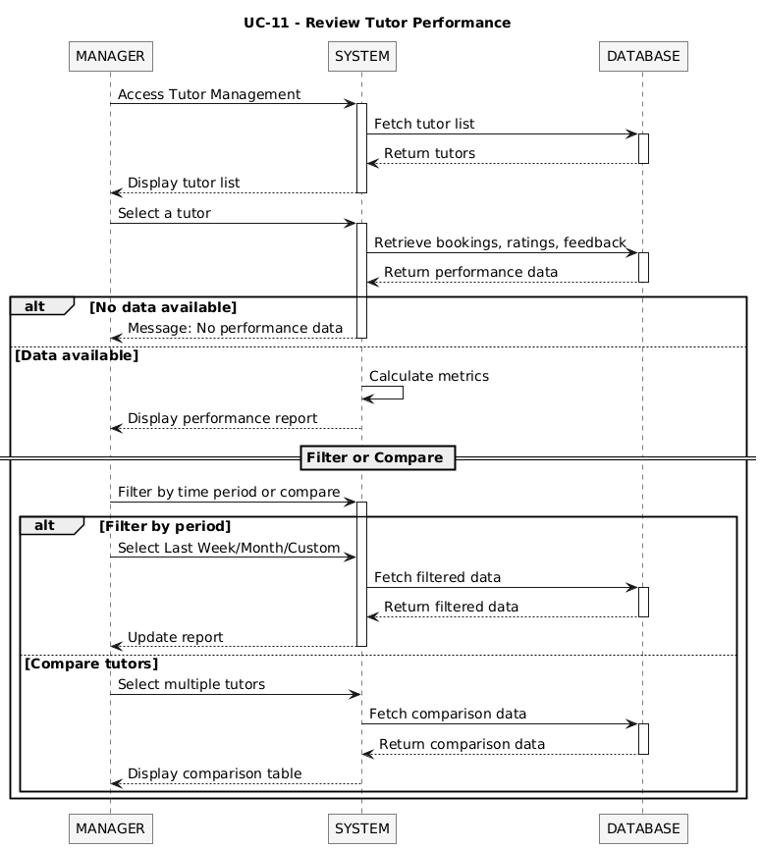
Figure 4(k): Review Tutor Performance
- Actors: Student, System, Database, Tutor
- Main Flow:
- Student logs in and navigates to the "Completed Bookings" or "Lesson History" section .
- System retrieves and displays a list of finished sessions that have not yet been reviewed.
- Student selects a specific lesson and chooses the "Write Review" action.
- Student enters review details: Rating (stars) and comments regarding the tutor’s teaching quality and attitude .
- System validates data: Ensures the review is not empty and the rating is within the 1-5 star range.
- System saves the review record to the Database.
- Database updates the Tutor’s overall rating profile based on the new feedback.
- System displays a success message and sends a Notification to the Tutor about the new review.
- Alternative Flow:
  - Edit/Delete Review:
- If the System allows, the Student can modify or remove their own review within a specific timeframe (e.g., 24 hours after posting) .
  - Invalid Review:
- If the session is not yet marked as "Completed" in the Database, the System restricts the review action and displays an error message.

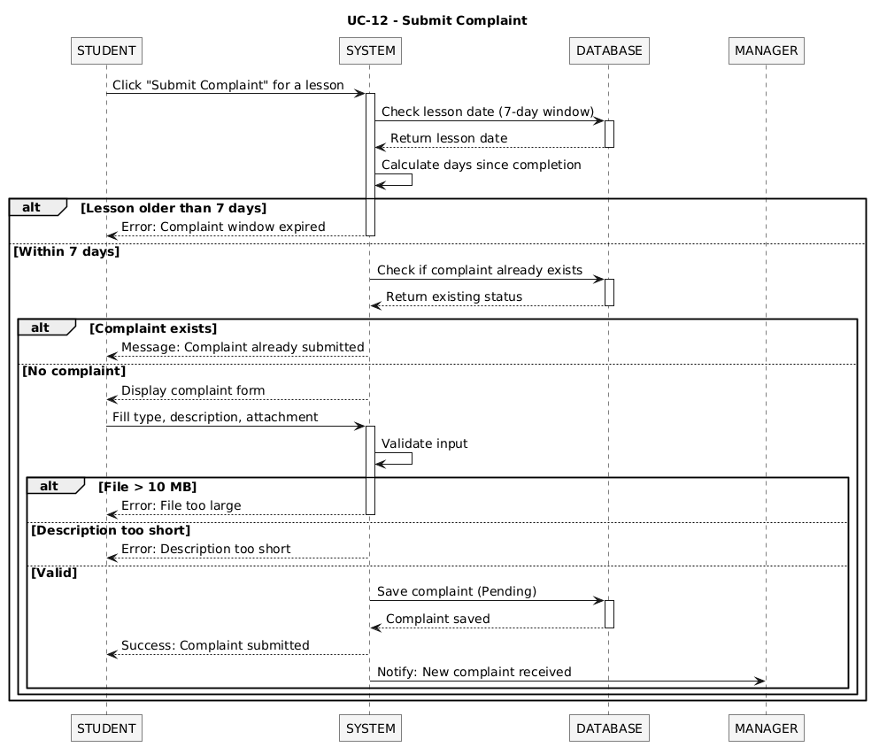
Figure 4(l): Submit Complaint

- Actors: Student, System, Database, Manager/Admin
- Main Flow:
- Student logs in and accesses the "Support" or "Transaction History" module to report a problem .
- Student selects the specific booking or tutor associated with the issue.
- Student enters complaint details: Category (e.g., tutor absence, payment error), description of the incident, and uploads supporting evidence (images or files) .
- System validates the request: Checks if all mandatory fields and evidence are provided.
- System creates a new complaint record with a "Pending" status in the Database.
- System notifies the Manager/Admin about the newly submitted complaint for investigation.
- Alternative Flow:
  - Withdraw Complaint:
- The Student can cancel the complaint if it has not yet been processed by the Manager. The System updates the status to "Withdrawn" .
  - Manager Response:
- Once the Manager reviews the evidence, they update the complaint status (e.g., "Resolved", "Rejected") and provide an explanation.
- System sends a notification to the Student regarding the final decision.

2.9.4 ACTIVITY DIAGRAM
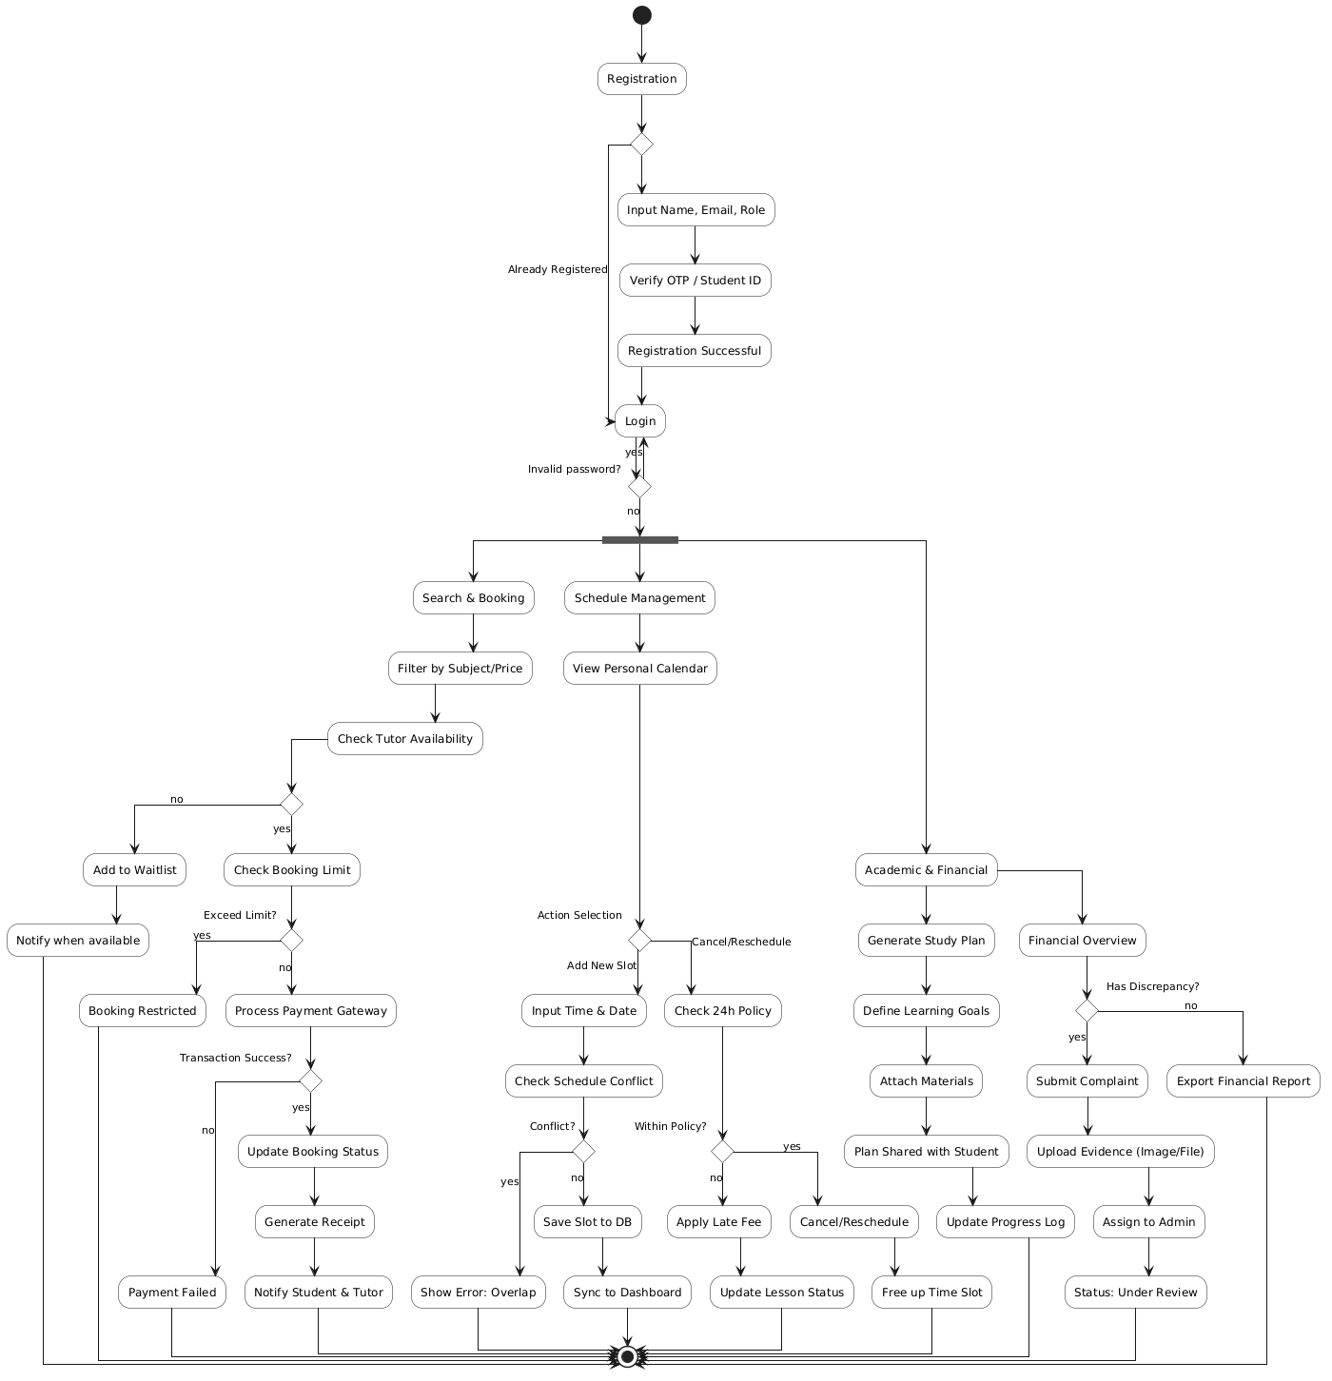
Figure 5: Activity diagram

The Activity Diagram illustrates the dynamic workflows of the HaNova Academic Mentoring Platform, detailing how various business processes are executed and how the system handles different logic branches. It provides a comprehensive view of the system’s operational flow, emphasizing user interactions and back-end validations .

2.9.4.1. Core Authentication Flow (Gateway)
This section defines the mandatory entry process for all users before they can access the platform's features.
- Registration Process:
  - New users must input their personal details (Name, Email, Role).
  - Verify Email OTP: The system triggers a mandatory verification step.
  - Decision: If the OTP is invalid, the registration fails and returns to the start. If valid, the user is successfully registered.
- Login Process:
  - Decision (Invalid Credentials?): The system validates the username and password. If incorrect, an error is displayed and the user must re-login. If correct, the user is directed to the main functional hub .

2.9.4.2. Synchronization and Functional Segmentation
The system uses a Synchronization Bar (SYNC_START) to split the workflow into four parallel or independent modules, ensuring a modular architecture :
- Search Tutor / Group: For booking and enrollment.
- Schedule Management: For time coordination.
- Academic Management: For learning materials and progress.
- Financial Management: For transactions and disputes.

2.9.4.3. Detailed Module Workflows
a. Search Tutor & Booking Module (Most Complex) This workflow handles the core revenue-generating activity of the platform :
- Availability Check: The system verifies if the tutor's time slot is free.
  - Alternative Path: If unavailable, the student is added to a Waitlist and notified later.
- Booking Permissions: The system checks if the student has exceeded their Weekly Booking Limit.
- Financial Processing:
  - The system applies vouchers and calculates the final fee.
  - Payment Execution: Triggers the payment gateway (VNPay/MoMo).
  - Decision (Transaction Success?): If payment fails, the student is redirected to the search page. If successful, the system updates the lesson status, syncs with Google Calendar, and sends a confirmation .
b. Schedule Management Module
Designed for both Tutors and Students to coordinate time slots:
- Add Slot:
  - Decision (Conflict Found?): The system checks the database for overlapping schedules. If an overlap occurs, an error is displayed. Otherwise, the new slot is saved.
- Cancel/Reschedule:
  - Decision (24h Policy Check): The system verifies if the request is within the allowed timeframe. If not, it applies a Late Fee automatically before canceling the session .
c. Academic Management Module
Focuses on the quality of mentoring and student progress:
- Study Plan Generation: Tutors define learning objectives and add session content.
- Validation: The system ensures the content meets quality standards. Once validated, the Study Plan is generated and shared with the student, and the Progress Tracker is updated .
d. Financial Management & Complaint Module Handles post-session administration and quality control :
- Invoice Check: Users review their financial balance.
- Dispute Handling:
- Decision (Issues Found?): If a student finds a discrepancy, they initiate the Submit Complaint activity.
- Evidence Collection: Users must attach images/files as proof. The complaint is then assigned to a Manager for final resolution.

2.9.4.4. Logical Indicators
To understand the diagram’s structure, the following notations are essential:
- Decisions (Diamonds): Represent logical branches (e.g., OTP valid?, Slot available?, Within policy?).
- Synchronization Bars (Solid Thick Lines): Indicate the start or end of parallel activities or the transition to multiple functional options.
- Termination (*): Indicates the end of a specific business process once the goal (e.g., booked, paid, or resolved) is met .

2.10 ER DIAGRAM

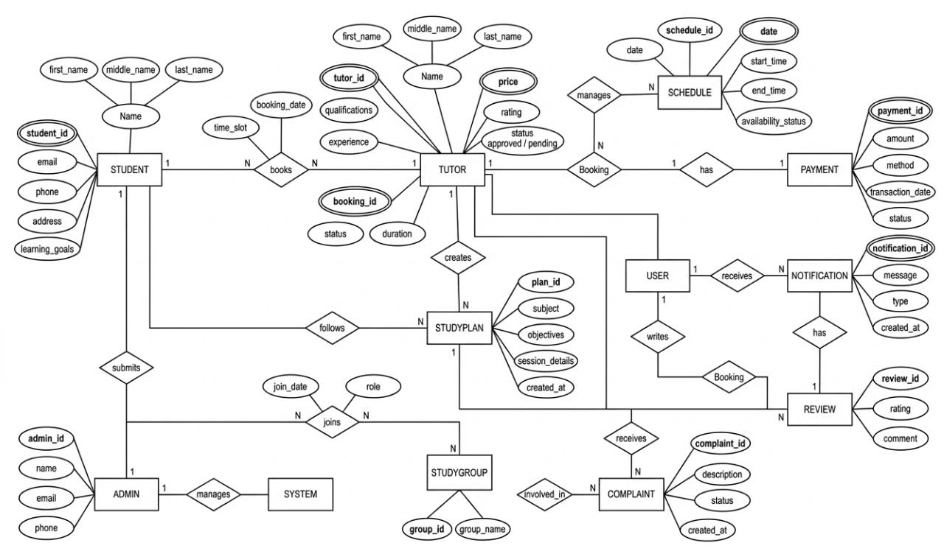
Figure 6: ER diagram

2.10.1. Core User Entities

The system includes Student, Tutor, Admin, and User entities.

Student: stores personal information and can book lessons, follow study plans, join study groups, and submit reviews or complaints.

Tutor: stores tutor information and manages schedules, bookings, and study plans.

Admin: manages system operations and user accounts.

User: supports common actions such as writing reviews and receiving notifications.

2.10.2. Booking and Scheduling

The Booking relationship connects Student and Tutor, representing lesson bookings with attributes such as booking_id, date, status, and duration.

The Schedule entity stores tutor availability (date, start time, end time, status).
A tutor can manage multiple schedules, ensuring proper time coordination and avoiding conflicts.

2.10.3. Payment Management

The Payment entity stores transaction information such as payment_id, amount, method, and status.
Each booking is associated with a payment, ensuring payment confirmation and tracking.

2.10.4. Academic Features

The StudyPlan entity represents learning plans created by tutors, while the StudyGroup entity supports group learning.

Students can follow study plans and join study groups, supporting both individual and collaborative learning.

2.10.5. Feedback and Quality Control

The system includes Review, Notification, and Complaint entities.

Review: stores ratings and comments after lessons.

Notification: stores system messages such as booking updates and reminders.

Complaint: stores user-reported issues for resolution.

These entities help maintain service quality and transparency.

2.10.6. Relationship Overview

Student ↔ Tutor: connected through Booking (N:N)

Tutor → Schedule: one-to-many

Booking → Payment: one-to-one

Tutor → StudyPlan: one-to-many

Student ↔ StudyGroup: many-to-many

User → Review/Notification: one-to-many

2.10.7. Data Characteristics

The ER diagram ensures:

Centralized data management

Data consistency and integrity

Support for full system workflow

Scalability for future development

2.11. Assumptions and Dependencies
The product needs following third party applications and assumptions for the development of the project:
- Visual Studio Code / IntelliJ: For development of the web-based mentoring platform.
- MySQL Workbench: For database management and ERD design.
- Photoshop / Figma: For editing layouts, icons, buttons, and user interfaces.
- VNPay / MoMo API: For processing online tuition payments.
- Stable Internet: Users are assumed to have a consistent connection for real-time booking.
- User Proficiency: Users are familiar with basic mobile and web application usage.

